CUSTOMER BEHAVIOR ANALYSIS

Data Analytics Internship – Task 1

Submitted By :
Dixita Vasireddy

Tools Used:
Python, Pandas, NumPy, Matplotlib, Seaborn, Jupyter Notebook

1.Objective :
The objective of this project is to analyze customer purchasing behavior, identify trends, customer preferences, and churn patterns using an E-Commerce customer dataset.
2.Dataset Description :
Dataset Name: ecommerce_customer_data_large.csv

The dataset contains customer transaction details including:
- Customer ID
- Purchase Date
- Product Category
- Product Price
- Quantity
- Total Purchase Amount
- Payment Method
- Customer Age
- Gender
- Returns
- Churn
3. Data Cleaning :
The following preprocessing steps were performed:

• Checked for missing values
• Filled missing numerical values using median
• Filled missing categorical values using mode
• Removed duplicate records
• Verified dataset consistency
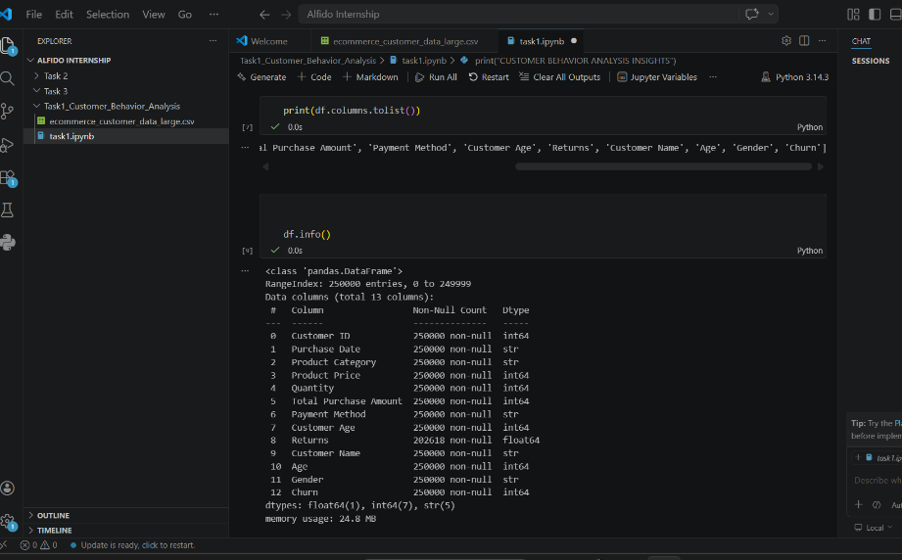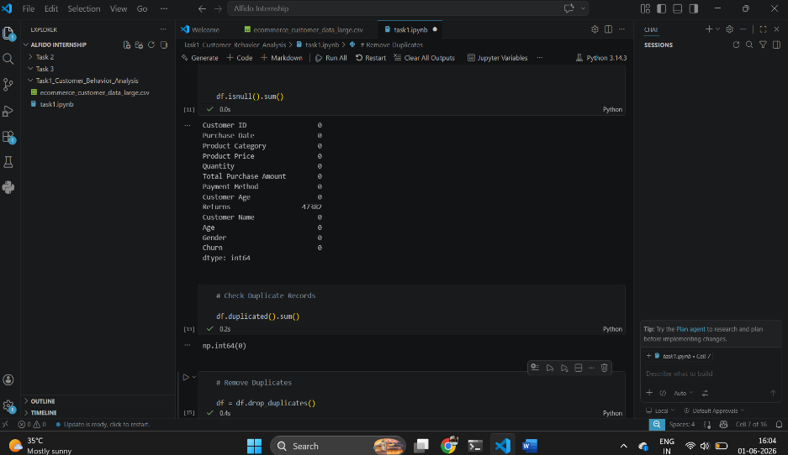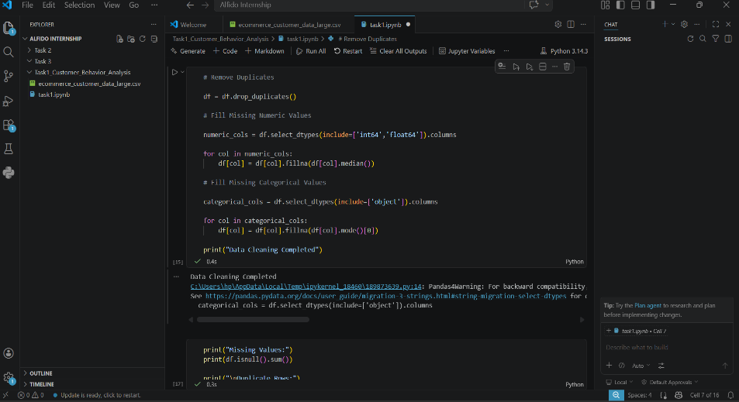
4. Product Category Distribution :
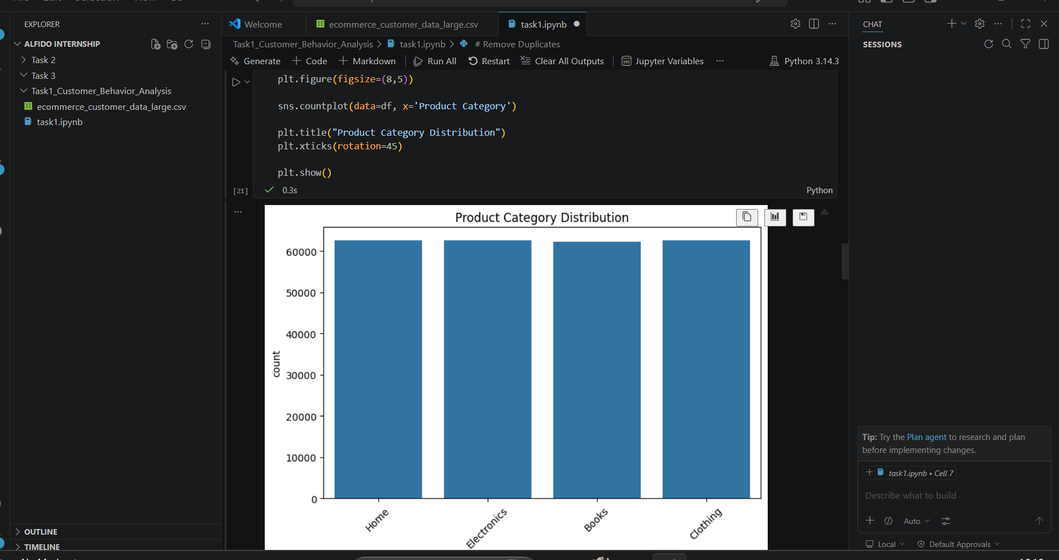
Observation:
The graph shows the distribution of purchases across different product categories. Some categories are more popular than others, indicating customer preferences.
Payment Method Distribution
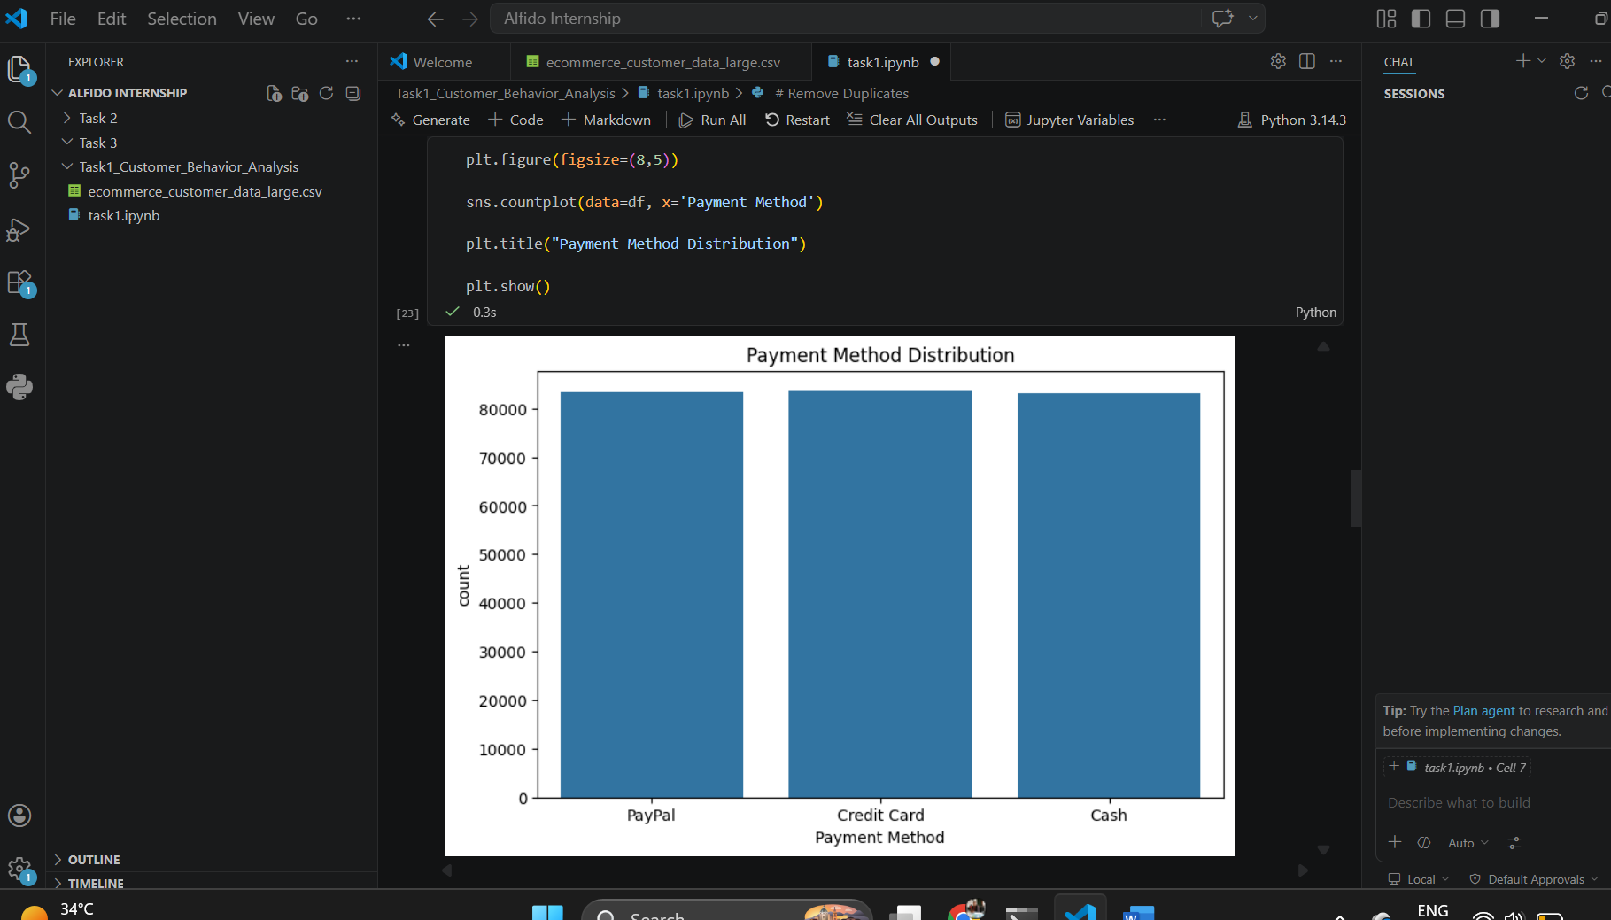
Observation:
Customers prefer certain payment methods over others, which helps businesses understand transaction behavior.
Gender Distribution :
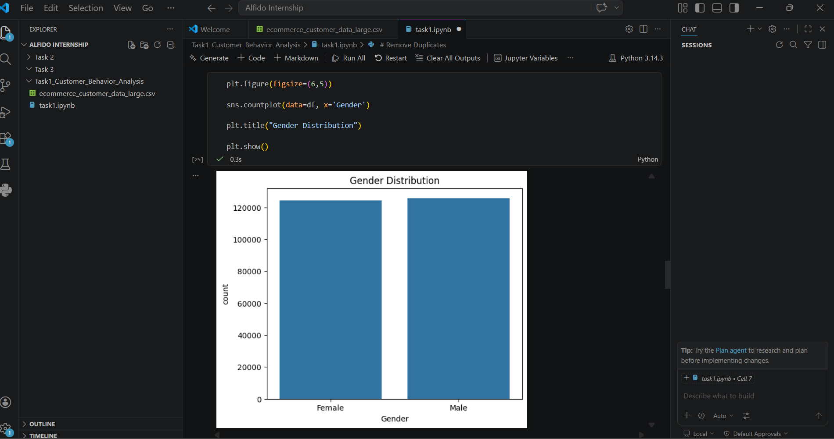
Observation:
The dataset contains purchases from both male and female customers, helping analyze demographic trends
Monthly Purchase Trend :
df['Purchase Date'] = pd.to_datetime(df['Purchase Date'])
monthly_sales = df.groupby(
df['Purchase Date'].dt.to_period('M')
).size()
monthly_sales.index = monthly_sales.index.to_timestamp()
plt.figure(figsize=(10,5))
monthly_sales.plot()
plt.title("Monthly Purchase Trend")
plt.xlabel("Month")
plt.ylabel("Number of Purchases")
plt.grid()
plt.show()
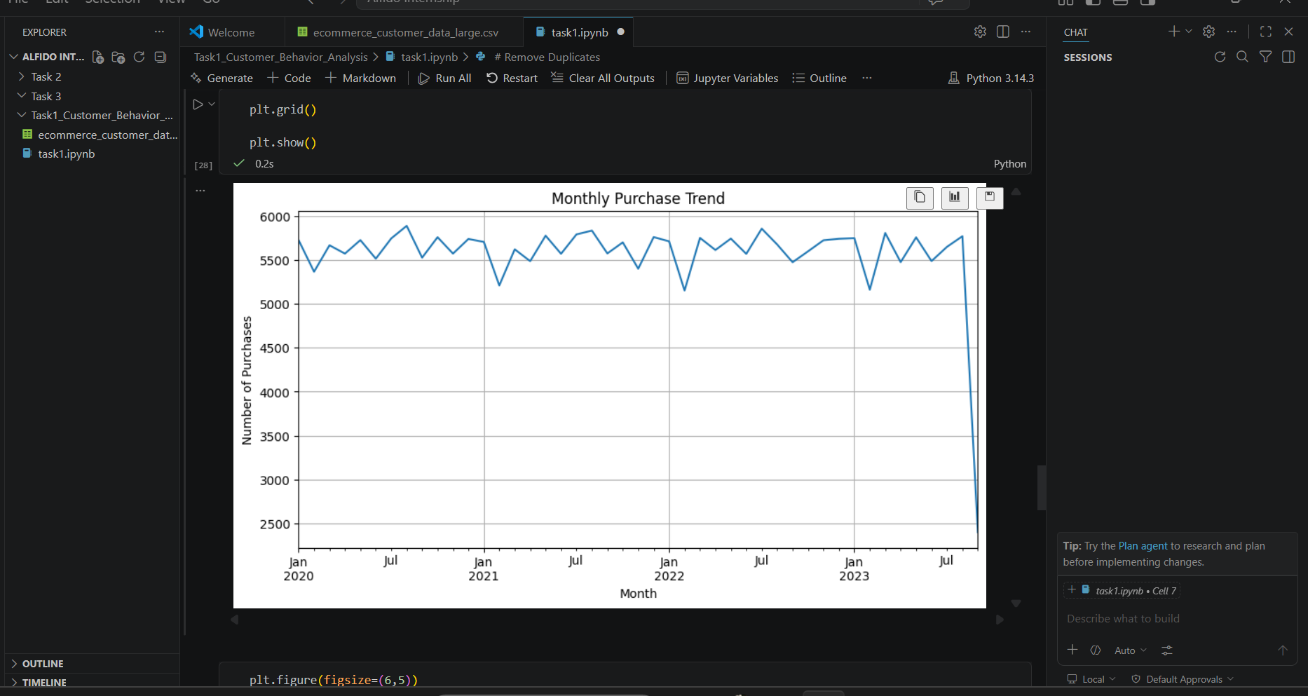
Observation:
Monthly purchase trends help identify peak sales periods and seasonal purchasing patterns.
Customer Churn Analysis :
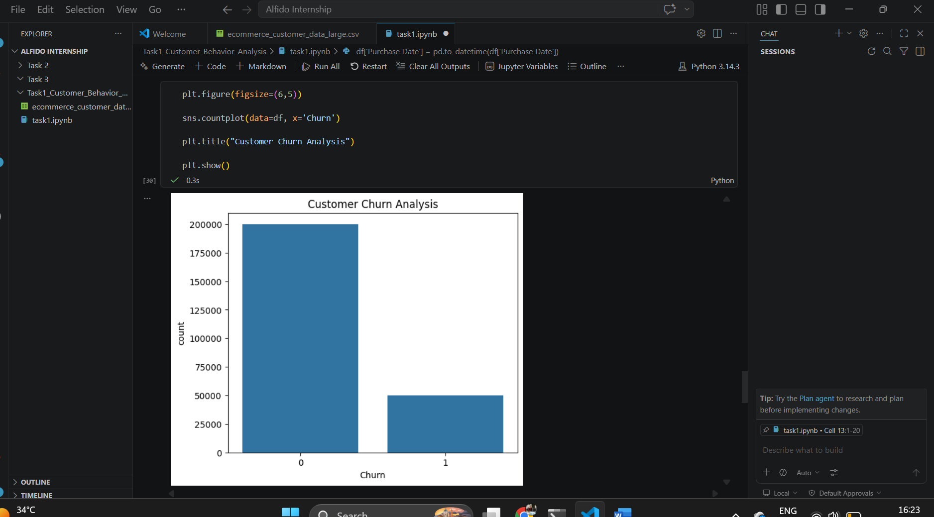
Observation:
The churn graph highlights the proportion of customers who stopped engaging with the business.
Correlation Heatmap
numeric_df = df.select_dtypes(include=['int64','float64'])
plt.figure(figsize=(10,6))
sns.heatmap(
numeric_df.corr(),
annot=True,
cmap='coolwarm'
)
plt.title("Correlation Heatmap")
plt.show()
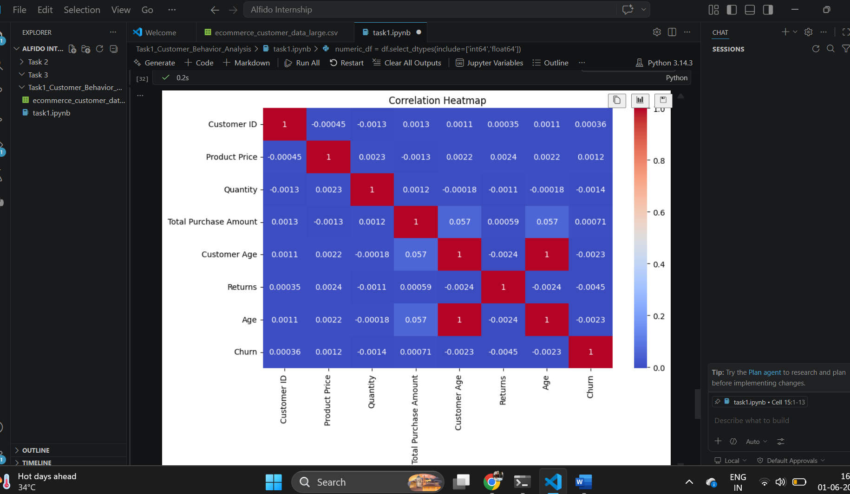

Observation:
The heatmap shows relationships between numerical variables. Strong correlations can help understand factors influencing purchase amounts.
5. Key Insights
CUSTOMER BEHAVIOR ANALYSIS INSIGHTS
1. Product categories reveal customer preferences.
2. Payment methods indicate customer transaction choices.
3. Monthly purchase trends identify peak sales periods.
4. Churn analysis helps understand customer retention.
5. Correlation heatmap shows relationships between numerical variables.
6. These insights can support marketing and customer retention strategies.

6. Conclusion
Customer behavior analysis provides valuable insights into purchasing patterns, customer preferences, and retention challenges. These findings can help businesses improve marketing strategies, customer engagement, and overall sales performance.

